Rishi Sharma

IT 520

10/1/18

Questions: (For each of these questions, take a screenshot of Wireshark, and attach it to your answer).

1. What is the IP address of your computer?

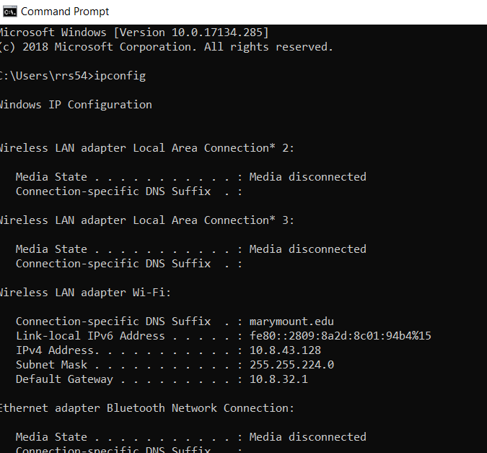

1. What is the total length of the datagram?

466

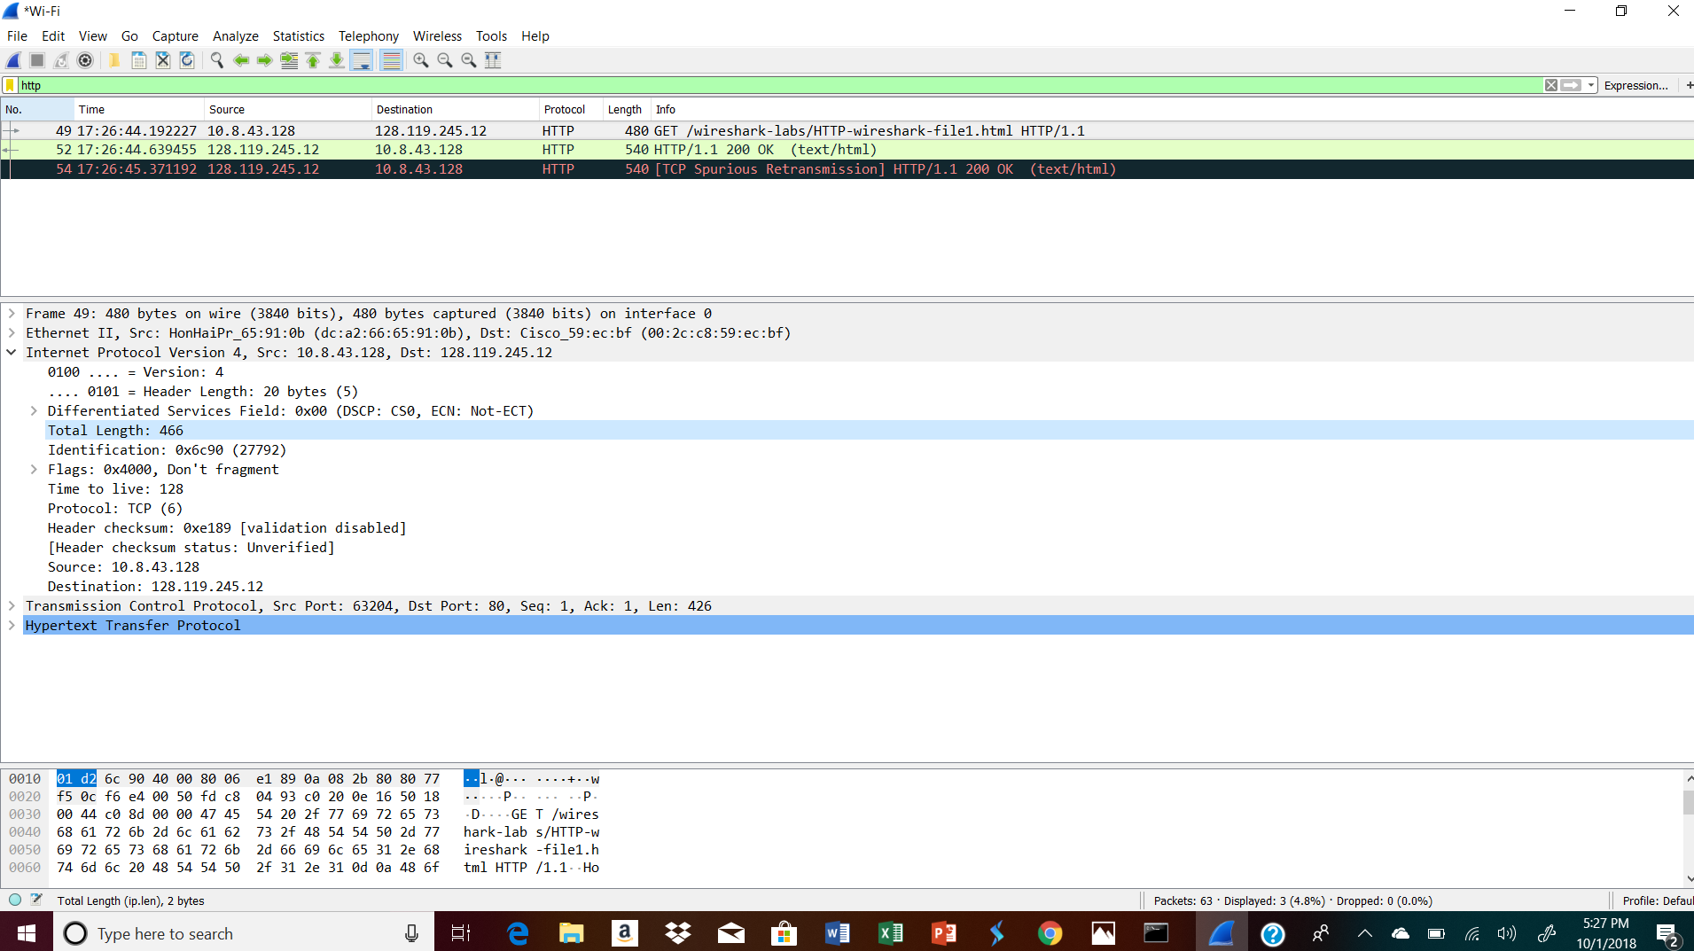

1. Has this IP datagram been fragmented?

Don’t Fragment because offset is set to 0

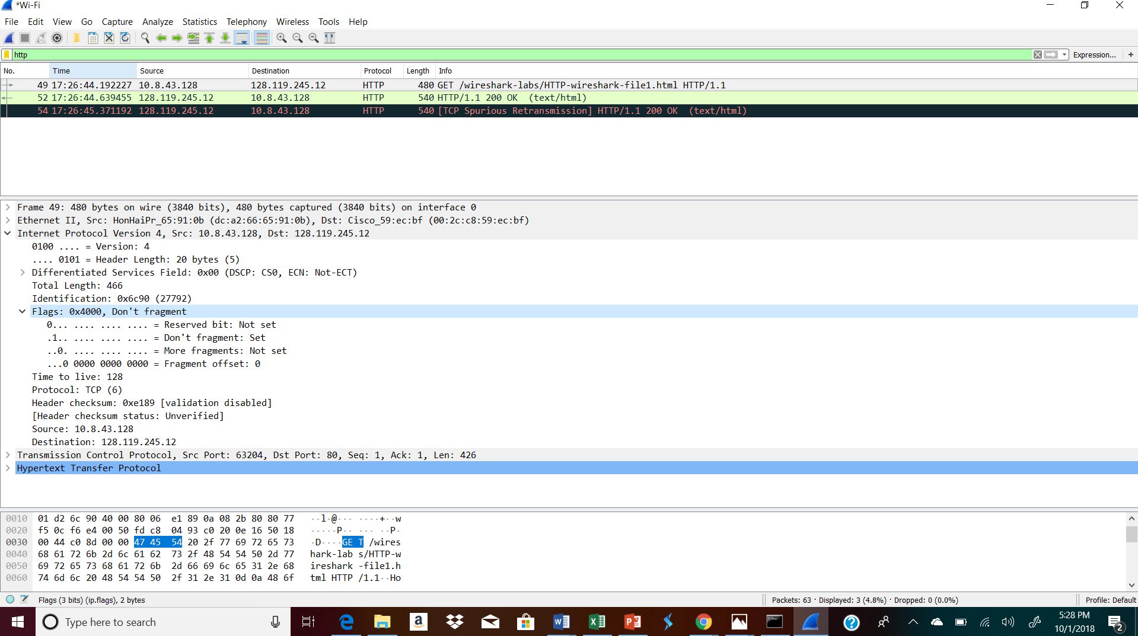

1. How many bytes are in the IP header?

20 Bytes

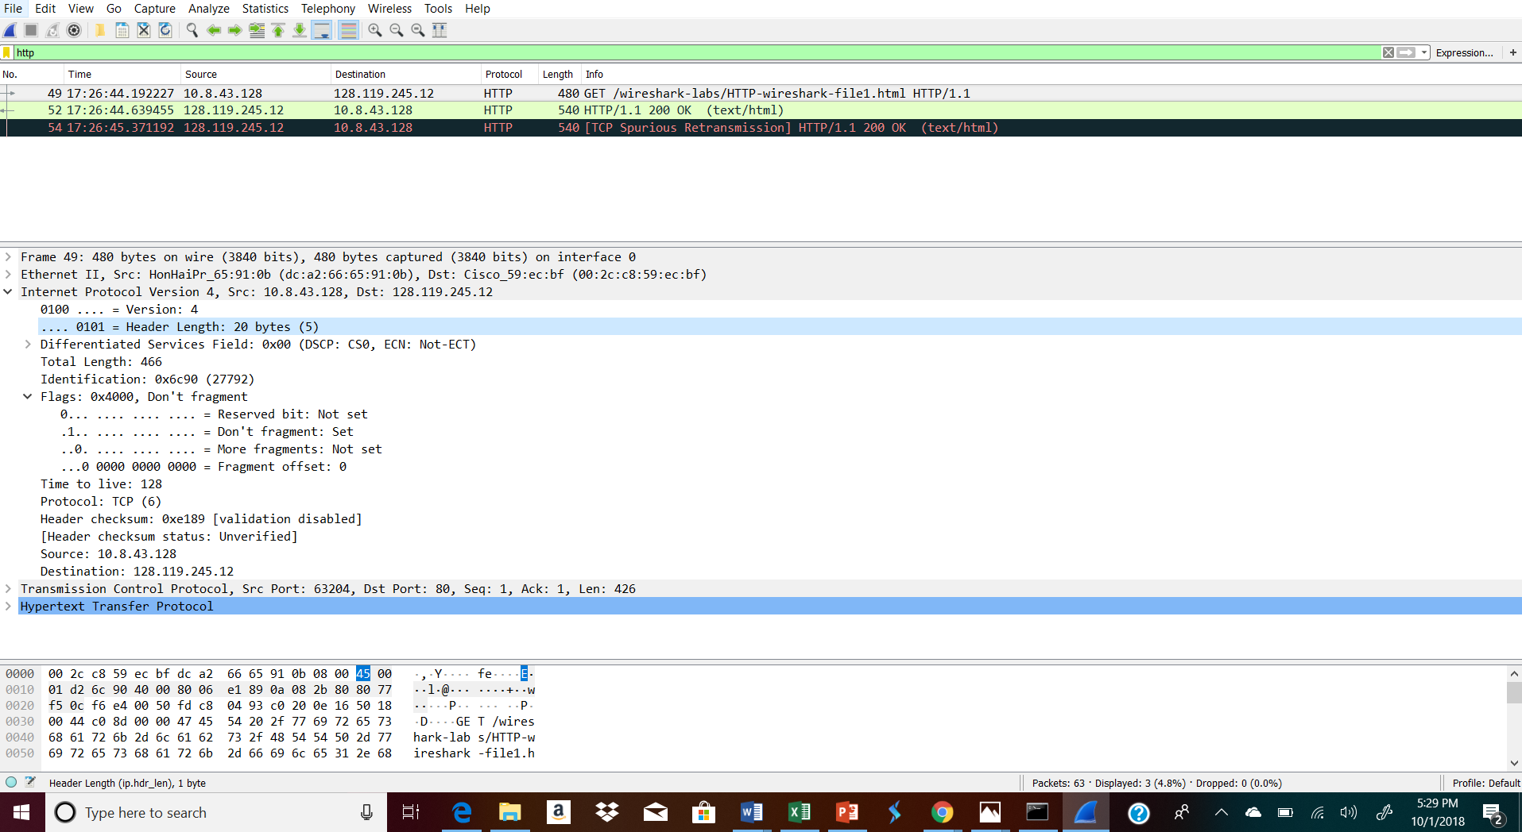

1. How many bytes are in the payload of the IP data?

446 bytes because I subtracted the 20 bytes (IP Header) from 466 (the total length)



